

# CTP 103 Course Project Part 2 Microsoft Word Memo Template – 50 points

##### Overview

In this part of the project you will use Microsoft Word to create a memo from a template. Review the Purdue Online Writing Lab Memo Guidelines document linked in the dropbox. In the memo, you will have the following sections.:

1. Heading – follow the instructions in Sections I and II to complete the heading.
2. Opening Segment – purpose of the memo
3. Choosing a college section – you will do a Google search on what students should look for when choosing a college and what mistakes to avoid. Use a minimum of three articles and paste the links at the end of the memo under your name. Write two or three paragraphs about what you found.
4. Top colleges section – write two to three paragraphs about the top 2-3 colleges from the research you did on colleges in Part 1 of the project. What factors do you find important in your search? How do they fit into your budget? What did you discover about the savings you realize from attending AACC for two years?
5. Research topic section – Finally, in the last paragraph, identify topic for your research paper. You can choose any topic in the course about which you would like to get curious. Remember that you will need to obtain scholarly articles about the topic (this means not just a web article).
6. Closing section

##### Section I – Creating a memo from a Word Template – 5 Points

Follow the instructions in [this video](https://youtu.be/stxKxXAmEC0) to create a memo in Word. The basic instructions are as follows:

1. Start Word.
2. Click **File** – **New.**
3. In the **Search for online templates** box, type **memo** and press **Enter.**
4. Choose **Interoffice Memo (Professional Design)**
5. 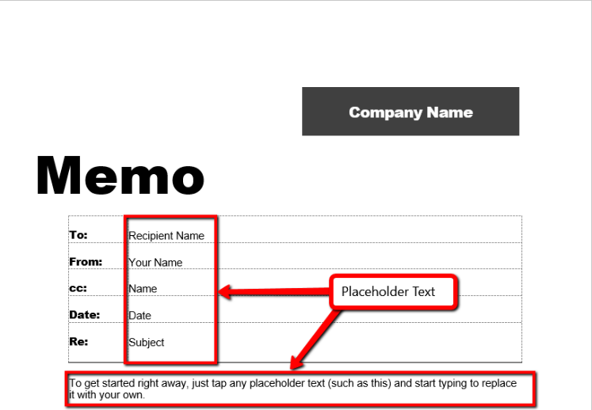Click **Create.** Your memo should look like this:

Notice that headings at the top (To:, From:, etc.) are a table. When you click in the cell after To:, it selects the entire **Recipient Name** text. This is called a **placeholder**. When you click on it and begin typing, it deletes Recipient Name and replaces it with what you have typed.

You need to delete the Company Name objects and the cc: row in the table before you are ready to complete the memo. Follow the instructions in the next section.

##### Section II – eDITING THE Memo tEMPLATE – 10 Points

1. 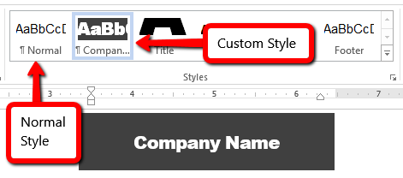The Company Name text is formatted as placeholder text and with a custom style called “Company Name”. If you just deleted the text, it would not change the style. So, delete the placeholder text and select the **Normal** style.
2. 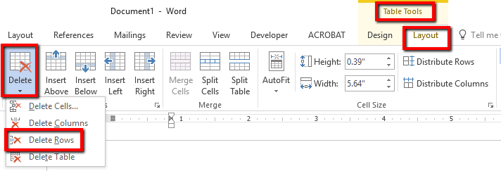Place your cursor in any cell in the **cc:** row. Select the **Layout** tab in the **Table Tools** contextual ribbon and select the **Delete** dropdown from the Rows & Columns group and select **Delete Rows** (see image below).
3. Now you should only have four headings at the top of the memo: To: (your professor’s name & title), From: (your name & your title as student), Date: (complete and current date), and Re: (type **College Search** **& Research Topic**)
4. Save the memo as **LastName_Memo.docx**.

##### Section Iii – Memo Formatting Guidelines – 35 points

1. A memo is organized into paragraphs, single-spaced, no indentation (block style) with a space between paragraphs. By default, Microsoft Word adds space after paragraph, so you only tap the Enter key once at the end of the paragraph.
2. The body of the text in the memo template is a placeholder so when you select the placeholder it selects all the text. You can begin typing and it will replace the placeholder text with your text.
3. The opening segment of a memo does not start such as “Dear Professor X”. You simply start with the purpose of the memo. You can start the first sentence with something like “I wanted to give you an update on my college search…” or “As you requested, this is an update to my college search…” Make sure this is a paragraph of two to three sentences with **NO section heading.**
4. For the next three sections use a section header for each of the following sections (NOTE: **you do NOT have a section header for the opening and closing segments.**)
   1. Choosing a college section – you will do a Google search on what students should look for when choosing a college and what mistakes to avoid. Use a minimum of three articles and paste the links at the end of the memo under your name. Write two or three paragraphs about what you found.
   2. Top colleges section – write two to three paragraphs about the top 2-3 colleges from the research you did on colleges in Part 1 of the project. What factors do you find important in your search? How do they fit into your budget? What did you discover about the savings you realize from attending AACC for two years? What has been your experience so far at AACC?
   3. Below the paragraph, you will insert your AACC Savings Chart (not the table) and insert a caption that says, “Data from College Board”. See [this video](https://youtu.be/ZsEecdw0dXc) for a demonstration.
5. Research topic section – identify the one topic for your research paper. You can choose any course-related topic. Your instructor will approve your topic.
6. Closing segment – in the last paragraph talk about how the exercise has helped you. You do not need to close with your name. (Remember, no section header in this section)
7. After the last paragraph, press Enter twice and type the title “References”, followed by pasting the links to the links to the references you used for #4a in a numbered list.
8. Make sure that you utilize spell check and proofread the memo to avoid grammar and spelling errors.

##### Other Memo Tips

* Use formal language. Instead of contractions (e.g. **can’t** or **didn’t**), use the long forms (**cannot**). Instead of phrasal verbs (e.g**. show up**), use non-phrasal verbs (**appear, arrive**). Avoid **you** when generalizing (specify the group of people you are referencing, e.g. customers); avoid **big** (substitute major, large).
* **Avoid** using ***be*** at all cost, especially in conjunction with ***there is*** and ***there are***.  Substitute active verbs.   
  **EXAMPLE 1:** The oil and gas industry ***is*** one of the top-ranked industries. **>** Oil and gas ***ranks*** among the top industries.  
  **EXAMPLE 2:** ***There are*** five industries in the group of industry leaders: **>** Five industries ***count*** (or ***rank***) among the leaders:
* **Avoid** using the passive voice. **Use active voice** instead. Express ***who is doing what to whom***.   
  **EXAMPLE:**Passive Voice: Computers ***are customized******by*** Dell Corporation according to customer specifications.   
  Active Voice: ***Dell Corporation customizes*** computers according to customer specifications.

##### Submission Instructions

1. Save the document as **LastName_Memo.docx**
2. Submit the assignment to the dropbox in Canvas by the due date.